Lab 5: Data Loading and Storage
Week 4 Lab Output Result
Alan B. Palayil
University of the Cumberlands
Course: ITS836 – Big Data Analytics
Instructor: Dr. Charles Edeki
Date: November 16th, 2025

Part 1: first 10 rows of the wine DataFrame with id.

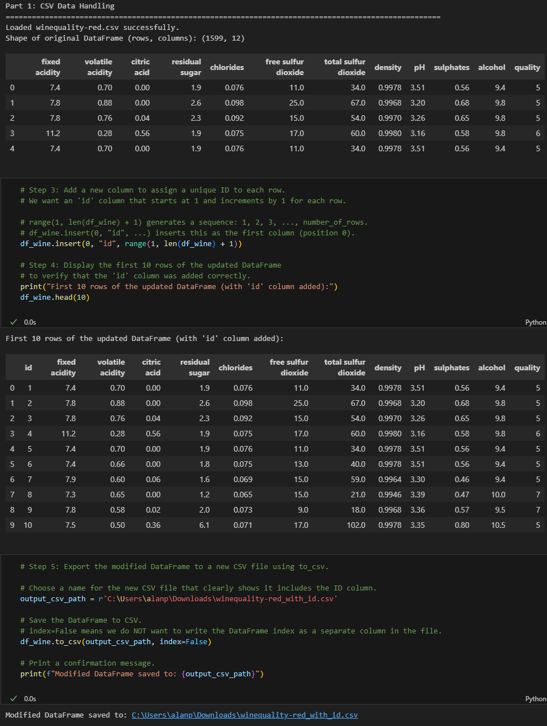

Part 2: JSON operations outputs.
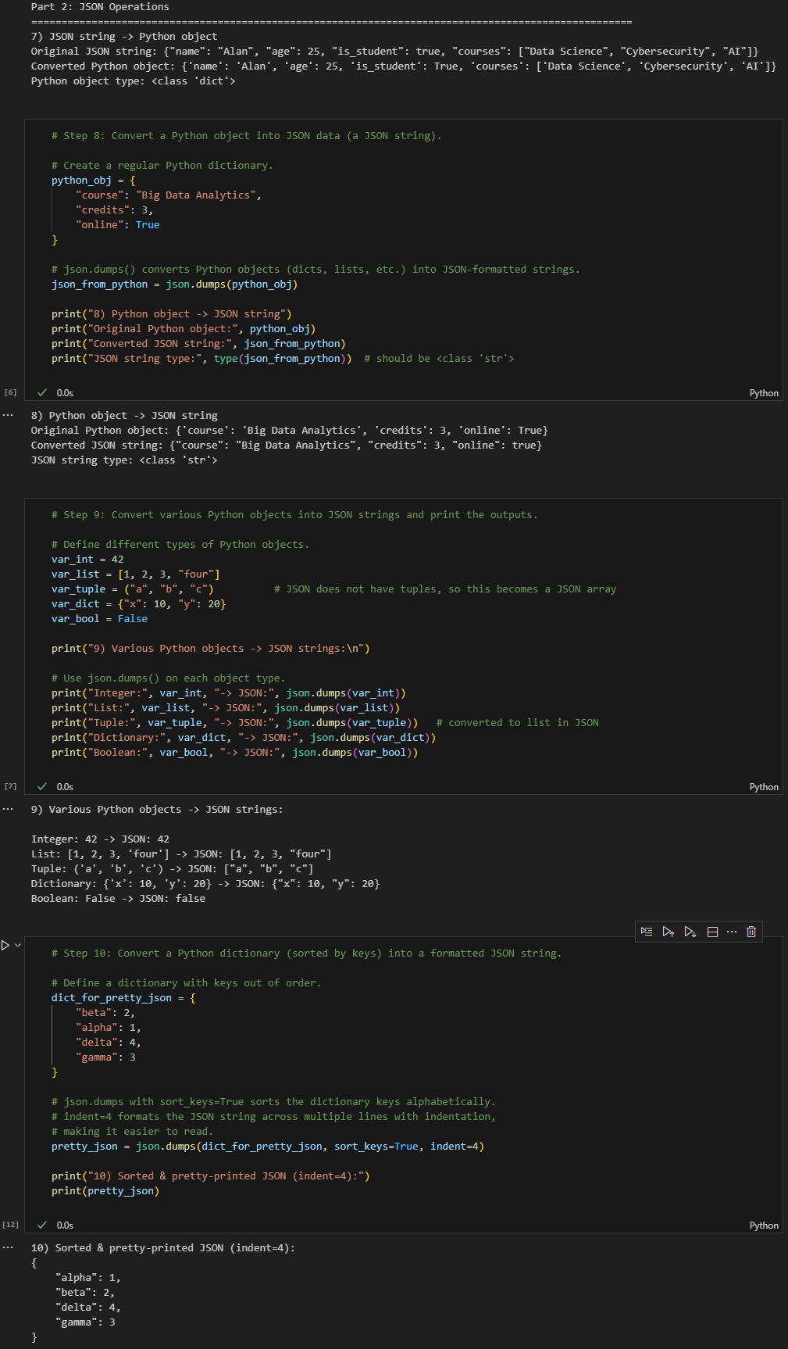

Part 3: player info + first few rows of the game log.
